AOD to T5 Swap In 87-93 Mustang
Is your AOD (Automatic w/ Overdrive) or A4LD (Automatic 4 Speed Light Duty) giving you trouble? Want to get rid of that slush box forever? Why don't you do an Auto to T5 swap! Finally, a place where you can get the low down on exactly what it takes to convert from an Auto to a Ford T5 transmission, step by step. First, lets look at what you'll need for the conversion.
If you want a printable checklist while you are doing the swap, left-click or right-click/save-as here:
Auto to T5 Checklist
Note: The parts listed are for a T5 or T5Z transmission. Swapping to an aftermarket tranny (example: TKO, 3550, T56, etc.) will require a slightly different list of parts. These questions may be answered in the new Q&A list that is under developement.
Needed Parts
- Starter index plate
- Bell housing/scatter shield
- Pivot ball
- T5/T5Z transmission
- Shifter
- Shifter knob
- Shifter weather seal
- Shifter boot
- Flywheel
- Clutch kit (pressure plate, clutch disc, and throw out bearing)
- Pilot bearing
- Clutch fork
- Clutch cable
- Clutch cable clip (secures the cable to the bell housing)
- Pedal Assembly
- Clutch quadrant
- Speedometer gear
- Back-up light harness (Ford part# E7ZZ-15525-A)
- T5 transmission cross member
- Exhaust hanger
Bolts:
- Upper bell housing bolts (or washers to make up the extra length)
- Pressure plate bolts
- Starter plate to bell housing bolt
- Transmission to bell housing bolts
Needed Tools
- Torque wrench
- Complete socket set (standard and metric)
- Screw drivers (phillips and flat head)
- Assortment of wrenches (standard and metric)
- 12 point, 12mm socket (for the driveshaft)
- O2 sensor socket (optional)
- Extension(s) approx. 36" long
- Jack
- Jack stands
Now that you have an idea on the parts and tools needed for the conversion, it's time to brake down the procedure. There are basically 2 parts: Under-the-car and inside-the-car. Under-the-car is the heavy, major conversion work. It's basically the removal of the Auto and the installation of the T5(Z). There is no real "modification" to be done. The only thing that needs to be "modified" is the opening for the shifter. The metal is so thin that it can be bent upwards for clearance. The inside-the-car work is basically the installation of the clutch pedal, clutch cable, relocation of the speedometer cable, and removal of the Auto's shifter. Other factoids will be given as the conversion is spelled out.
INSIDE THE CAR
The only reason that I suggest starting with the inside is so that you have room for the shifter when you install the transmission and something to hold on to the clutch fork when installing the T5. This will be clearer as you read the step-by-step instructions.
Removal of the automatic pedal assembly
- Remove the front drivers seat. This will make removing the pedal assembly A LOT easier.
- Remove the plastic cover around the steering column and under the dash.
- Remove the hood release cable bracket.
- Lower the steering column. There are 4 nuts that support the steering column. As you are lowering the column, unplug the wires so that they don't get taught and support the column.
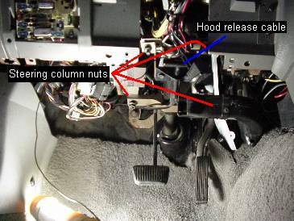
- Remove the nut and bolt from the top of the pedal assembly
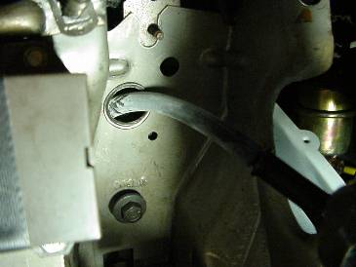
- Remove the brake booster rod from the brake pedal
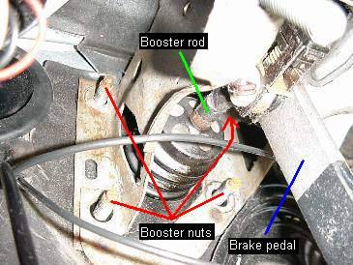
- Remove the 4 nuts on the back of the fire wall (brake booster nuts). The upper left nut is the hardest one to get to. If you look carefully, you can get a ratchet/extension/socket to remove it.
- Wiggle the pedal assembly out from under the dash. This is the hardest part. Take your time and try not to get upset. Take a breather or two if you are having trouble.
Relocation of the speedometer cable and install of the clutch cable
- Remove the head light switch.
- Remove the hazard lights switch.
- Remove the gauge cluster cover.
- Remove the gauge cluster. There are 2 plugs and the speedometer cable holding it back. Don't force the gauge cluster away from the dash too hard.
- Pull the speedometer cable out from under the hood.
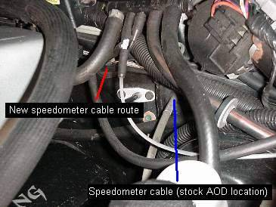
- Reinstall the speedometer cable through the other hole. If you look directly to the left of where the speedometer cable came out of, you'll see the hole where the speedometer cable needs to go through.
- Reinstall the gauge cluster.
- Reinstall the gauge cluster cover.
- Reinstall the hazard and headlight switches.
Install of the manual pedal assembly
- Wiggle the pedal assembly into place.
- Reinstall the 4 nuts that go to the brake booster.
- Reinstall the nut and bolt on the upper portion of the pedal assembly.
- Install the clutch cable though the original hole for the speedometer cable.
- Plug the neutral safety switch. The clutch neutral safety switch plugs are already wired in every Mustang. Look under the dash for them. They will be taped up with the main wiring harness.
- Reinstall the brake booster rod to the brake pedal.
- Raise the steering column and plug the wires associated with the column.
- Reinstall the hood release cable bracket.
- Reinstall the plastic panels under the dash and around the steering column.
- Reinstall the front drivers seat.
UNDER THE CAR
Here is where the work requires muscle. Having a few friends, or calling in a favor, would be a good idea at this point.
Removal of the AOD
- Jack up the car as high as you can.
- Disconnect the battery
- Remove the H-pipe.
- Remove the driveshaft. It would be a good idea to plug the tail end of the transmission with another driveshaft yoke to prevent fluid spillage.
- Remove the inspection plate in front of the transmission.
- Unbolt the torque converter from the flex plate. Use a socket/extension/ratchet on the harmonic balancer bolt to help turn the motor to get to the other nuts.
- Remove the starter.
- Disconnect the TV (Throttle Valve; cable to the throttle body) and shifter cable. Make sure that you also remove their respective cable brackets.
- Remove the transmission cooler lines. If you don't plan to ever put an Auto back in, hack away.
- Remove the transmission cross member. Make sure you have the floor jack supporting the transmission before removing the cross member.
- Remove the upper transmission bolts. Lowering the floor jack to allow the engine/transmission to tip back will give you access to the top bell housing bolts easily. Use the 36" long extension to help with removal.
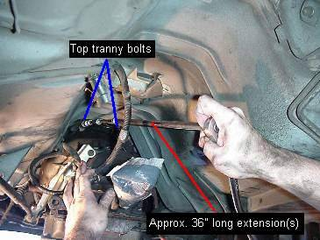
- Raise the transmission back up. Before taking out the lower bolts, raise the transmission so that it doesn't slide from the jack.
- Remove the lower transmission bolts.
- Lower the transmission. You'll have to shake the transmission a bit and pull backwards to get it away from the engine.
- Slide the transmission out from under the car. Unless you have really tall jacks, you'll have to raise the rear of the transmission to clear the floor pan of the car. Bolt the inspection plate back on the transmission to prevent the torque converter from falling out and spilling transmission fluid everywhere.
Rear Main Seal (optional)
There you have it. The Auto is now out of your car. Before installing the T5, now would be a good time to change the rear main seal. Many 5.0's are plagued with the rear main seal leaking. This is a great time to kill two birds with one stone. All it takes is a flat head screw driver and a hammer to pop it out. Just make sure you done nick the crank. Hit the screwdriver slowly.
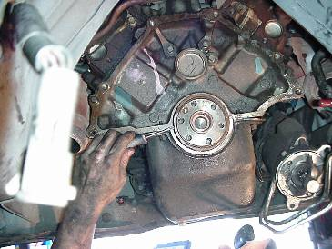
When installing the rear main seal, just use a blunt object and hammer to tap it in. Make sure you go around evenly as to not warp the seal and cause it to leak.
Auto Shifter Removal
Now that you have room under the car, undo the cable to the shifter. After you have done this, its a matter of unscrewing the 4 bolts inside the car to remove the shifter. The hole in the center console is a too tight for the shifter. The console plate will come out with some force applied upwards. It will look like it's about to break and then the clips will let go and it will come loose. After pulling out the shifter, you'll need to make more room for the T5(Z)'s shifter. The front part of the opening in the floor pan can be hammered up or you can cut about 1/2" more length for the hole.
Install of the T5(Z)
- Install the pilot bearing. Don't strike the pilot bearing with a hammer directly. Place an over sized socket on the pilot bearing and hit the socket.
- Place the starter index plate on the back of the block. To help hold the starter plate, use a couple bell housing bolts to secure the plate to the block while you install the flywheel and clutch.
- Install the flywheel. You can use the Auto's flexplate bolts for this. Torque them down to 75-85lbs.
- Place clutch on the flywheel. Use a clutch alignment tool to hold the disc onto the flywheel.
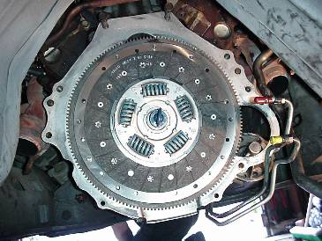
- Bolt the pressure plate to the flywheel. Torque the pressure plate bolt to 12-24lbs.
- Remove the clutch alignment tool. I know it seems stupid to put this step but I knew a person that didn't reinstall a radiator cap cause it didn't say so on the back of the bottle!!
- Install the bell housing. Torque the bolts to 39-54lbs.
- Place the clutch fork in the bell housing. This can be done by routing the fork from the rear opening towards the side opening on the bell housing.
- Install the throw out bearing. I find it easier to place the fork in the bell housing first, then install the bearing.
- Install the clutch cable. Having the clutch cable hold the fork makes it easier to install the tranny.
- Bolt the tranny to the bell housing. Make sure that the shifter is already installed but not the handle. Having the handle installed just make it harder to install the tranny cause it can hit the floor pan of the car. Torque the bolts to 36-50lbs.
- Install the cross member and exhaust hanger. Auto cross member and exhaust hanger are different. You might be able to get away with grinding the cross member, but the exhaust hanger will interfere with the VSS on the T5.
- Change the Auto's neutral safety switch to a T5(Z)'s reverse light switch. The Auto's wiring harness for this consists of 4 wires. In most cases, this section of wire can be replaced with a simple 2-wire T5 harness. The 2 wires go to the reverse light switch and the other 2 wires are connected with a jumper wire already on the harness. If you find out there are drivability problems, you may have to also connect the neutral switch on the tranny.
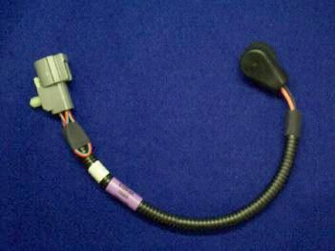
- Install the clutch cable cover. Do this now unless you have an aftermarket clutch cable that adjusts on the fork. Adjust the cable first, then put the cover on.
- Fill the transmission with ATF fluid (I prefer Synthetics). I like doing this at this point since the exhaust isn't in the way yet.
- Change the Auto speedometer gear to a T5 speedometer gear. There is a different gear for different differential gear ratios. Consult your SVO supplier for the proper gear.
- Install the driveshaft. Torque the bolts to 70-95lbs.
- Install the Exhaust Pipe.
- Install the O2 sensor(s).
This completes the installation of the T5(Z). Only thing that need to be done at this point is to install the rubber shifter seal (not recommended with aftermarket shifters; they can eventually rip the rubber) and installing the shifter boot. Now you can enjoy the feeling of shifting your own gears.
Questions and Answers
Read this step-by-step and you still have questions? In this section, I hope to add questions and answers that are most commonly asked.
Q Do I need a manual computer?
A No, you do not. The Auto computer will work fine with the T5 without any modifications and/or alterations.
Q Do I need a new driveshaft?
A No, you do not need a new driveshaft for a T5. However, if you are swapping in a TKO, T56, or other aftermarket tranny, you will need a new driveshaft, new yoke, or at least modify your current one. Best way to find out exactly what you need is to contact the manufacturer of the transmission.
Q Do I need a new crossmember?
A You don't need a new crossmember, but it will have to be modified to fit a T5 tranny if you want to reuse it. You'll need to grind the motor mount slots, or grind the weld spots on the bushing cylinders so that you can move the crossmember and line it up with the tranny mount. Its a lot easier to get a used T5 crossmember and the price is usually not too much. If you are swapping in a tranny that is longer than a T5 (Example: TKO), the Auto crossmember will work fine.
Q Will a pedal assembly work from an '86-older Mustang in a '87-'93?
A Yes, an '84-'86 pedal assembly will work in an '87-'93 Mustang
QWill a 4-banger pedal assembly work in a 5.0L Mustang?
A Yes and no. A 4-banger pedal assembly frame will work. However, the clutch pedal arm is shorter on a 4-banger Mustang. You can use a 4-banger pedal frame with a 5.0L clutch arm.
Q Can I reuse the flex plate bolts?
A You may be able to, but to be on the safe side, get bolts for a flywheel from your local Ford dealer. I have heard cases where people try to use the flexplate bolts and end up stripping the crank because the bolts are not long enough.
Q Can I reuse the Auto exhaust hanger?
A No, you cant. A T5 exhaust hanger is needed. Some people have done the swap deleting the exhaust hanger. It's possible, but not recommended.
Q Can I reuse the speedometer gear?
A Not unless you are using the 5 Speed car's rear end as well. The speedometer gears for a T5 and Auto are different ratios.

